Setting Up and Managing a Web Server on Linux: Installation, Configuration, and Deployment
A web server is a software or hardware system designed to deliver content, such as web pages, to users over the Internet or an intranet. When a client (such as a web browser) requests a page using HTTP or HTTPS (e.g., by typing a URL into the browser), the web server processes the request, retrieves the content, and serves it back to the client.

Key Components of a Web Server:
- Hardware: The physical machine where the web server software runs. It can be a simple desktop or a high-performance server.
- Software: The application responsible for handling HTTP/HTTPS requests and delivering content. Common web server software includes:
- Apache HTTP Server: An open-source, widely used web server.
- Nginx: Known for high performance and efficiency.
- Microsoft IIS (Internet Information Services): Used on Windows servers.
- LiteSpeed: A high-performance commercial web server.

How Does a Web Server Work?
- Client Request: A user sends a request to the server through a browser or application, typically by entering a URL or clicking a link.
- Request Handling: The web server receives the HTTP/HTTPS request and processes it.
- Content Retrieval: The server locates the requested content (e.g., HTML files, images, videos, or dynamic content generated by scripts).
- Response: The web server sends the requested data back to the client.

Types of Web Servers:

Static Web Server:
- Serves only static content like HTML, CSS, and images.
- No ability to generate content dynamically.

Dynamic Web Server:
- Combines a web server with additional software, like an application server and database.
- Generates dynamic content using languages such as PHP, Python, or Ruby.

Common Use Cases:
- Hosting websites or applications.
- Supporting APIs for mobile and web apps.
- Delivering files or media for content distribution.

Examples of Web Server Usage:
- A university's website that displays course offerings.
- An e-commerce site delivering product details and processing user requests.
- Hosting web applications like Gmail or Facebook.
Web servers play a vital role in the infrastructure of the World Wide Web, acting as a bridge between users and the vast amount of data available online.

Installing a Web Server

Install Apache
sudo apt update
sudo apt install apache2 -y

Check Installation
apache2 -v

Start the Service
sudo systemctl start apache2

Enable on Boot:
sudo systemctl enable apache2

Status Checking and Basic Management

Check Status
sudo systemctl status apache2

Restart the Service
sudo systemctl restart apache2

Stop the Service
sudo systemctl stop apache2

Access the Default Web Page
- Open a browser and navigate to http://localhost
- You should see the default Apache

Running a Simple Web Application

Create a Sample HTML Page
echo "<h1>Welcome to My Web Server</h1>" | sudo tee /var/www/html/index.html
This command creates (or overwrites) an HTML file named index.html in the /var/www/html directory with the content <h1>Welcome to My Web Server</h1>

Command Breakdown

1. echo "<h1>Welcome to My Web Server</h1>"
- The echo command outputs the text <h1>Welcome to My Web Server</h1> to standard output (the terminal screen by default).
- In this case, it's an HTML snippet that creates a header (<h1>) to display the message.

2. | (Pipe Operator)
- The | operator takes the output from the command on its left (echo) and passes it as input to the command on its right (sudo tee).

3. sudo tee /var/www/html/index.html
- sudo: Executes the following command with superuser (root) privileges, which are required to write files in the /var/www/html directory because it's owned by the root user.
- tee:
  - Reads standard input (from echo) and writes it to both standard output (so you can see it on the terminal) and the specified file (/var/www/html/index.html).
  - Unlike redirection (>) which overwrites files, tee can work with sudo privileges to write directly to root-owned files.
Here, sudo tee creates or overwrites the index.html file in the /var/www/html directory with the content from echo.

Why Use This Command?
Direct File Writing to Root-owned Directories: Since /var/www/html is typically owned by root, normal redirection (> or >>) may fail due to insufficient permissions. Using sudo tee allows you to write to such directories without manually switching to the root user.

Result
- A file named index.html will be created in the /var/www/html directory containing the text:
<h1>Welcome to My Web Server</h1>

File Location
- /var/www/html/index.html is the default document root for many web servers like Apache or Nginx on Linux systems.
- If a web server is configured correctly and you visit the server's IP or hostname in a browser, this index.html will be served as the default page.

tee command
The tee command in Linux does not literally stand for an acronym; instead, its name comes from the plumbing terminology of a "T-junction," which splits a flow into two directions. The tee command behaves similarly by splitting the data it receives:
- It takes input (from stdin) and "splits" it by writing it to a file (or multiple files) and outputting it to the terminal (stdout) at the same time.

Key Idea:
Think of a pipe (|) carrying data that branches into two outputs, much like the tee command splits the input.

How It Works:
- Receives input from standard input (stdin) — e.g., piped output from another command.
- Writes to one or more files (the main functionality of the tee command).
- Displays output on the terminal (stdout) simultaneously.

Example:
echo "Hello, World!" | tee hello.txt
This does the following:
- Takes the Hello, World! string from the echo command.
- Writes it to the hello.txt file.
- Displays the same text on the terminal.

Common Flags for tee:
- -a: Append data to the file instead of overwriting it.
echo "Appended Text" | tee -a file.txt

Restart the Web Server
sudo systemctl restart apache2

Test Your Application:
- Open http://<server_ip> in your browser to view the new page.

Configuring Virtual Hosts

Create a Directory for a New Website:
sudo mkdir /var/www/example.com
echo "<h1>Welcome to Example.com</h1>" | sudo tee /var/www/example.com/index.html

Set Directory Permissions:
sudo chown -R $USER:$USER /var/www/example.com
sudo chmod -R 755 /var/www/example.com
In Linux, the format $USER:$USER specifies the user and the group that will own the directory or files. By default, Linux assigns the same group name as the username.
For example, if your username is "Ahmad", using $USER:$USER would set both the owner and the group of the files to "Ahmad". In this case, Ahmad is the user, and the group is also named "Ahmad".
If you want to assign a different group, you can use the format user:group. For instance, if your username is "Ali" and you want to set the group to "developers", you would use Ali:developers. This would make "Ali" the owner and "developers" (the group) the group owner of the directory/files.
Another example: if you want to make "Fatima" the owner and "www-data" (commonly used by web servers) the group owner, you would use Fatima:www-data.

Create a Virtual Host Configuration File (Apache Example):
sudo nano /etc/apache2/sites-available/example.com.conf
Add the following:
<VirtualHost *:80>
ServerName example.com
DocumentRoot /var/www/example.com
ErrorLog ${APACHE_LOG_DIR}/error.log
CustomLog ${APACHE_LOG_DIR}/access.log combined
</VirtualHost>

Enable the Configuration:
sudo a2ensite example.com.conf
sudo systemctl reload apache2

Test the Configuration:
- Access the virtual host via http://example.com (ensure DNS is set up or add entry to /etc/hosts and add 127.0.0.1 example.com in it and Restart Apache)

Security and Logs

Enable a Firewall:

Allow web traffic:
sudo ufw allow 'Apache Full'

Check status:
sudo ufw status

View Logs:

Apache Logs:
sudo tail -f /var/log/apache2/access.log
sudo tail -f /var/log/apache2/error.log

Practice Questions
- Secure Your Web Server with a Firewall and Validate Access Using curl
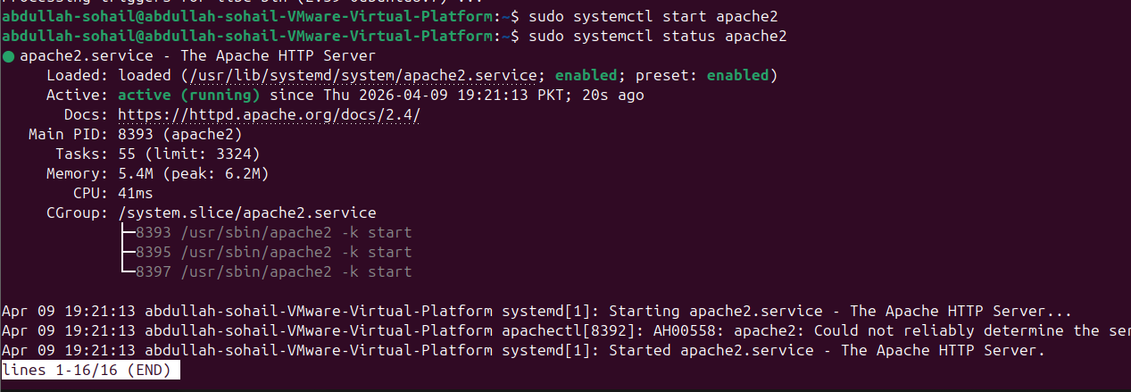
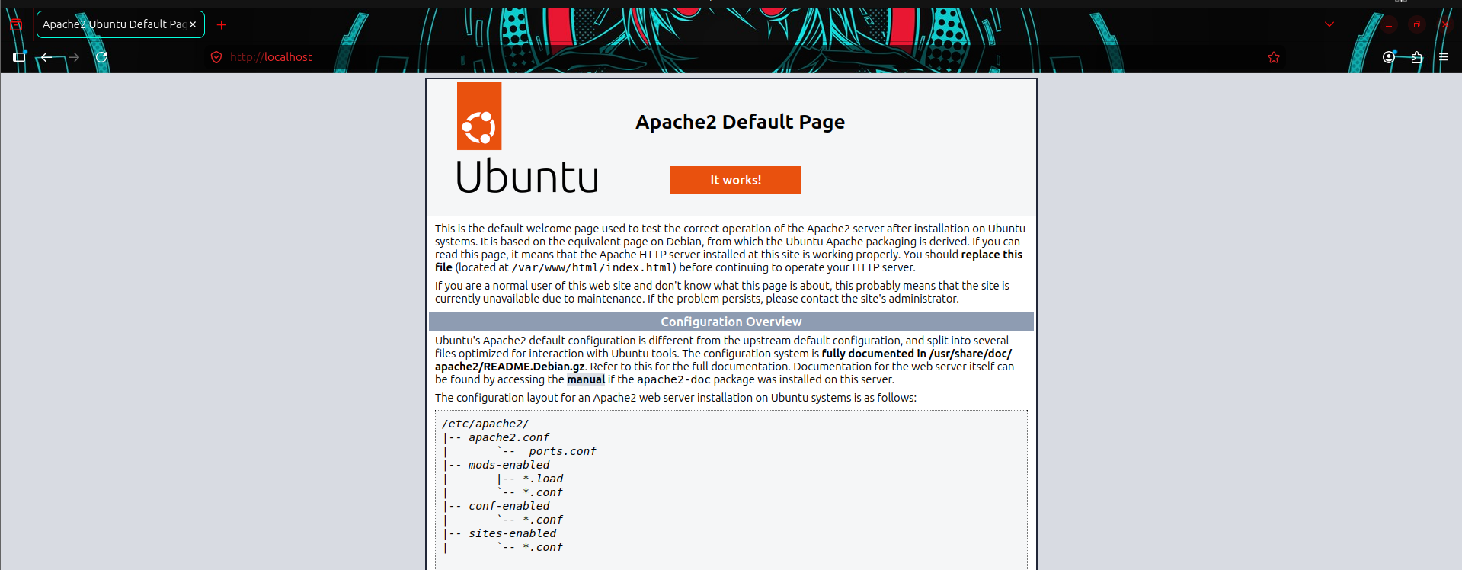
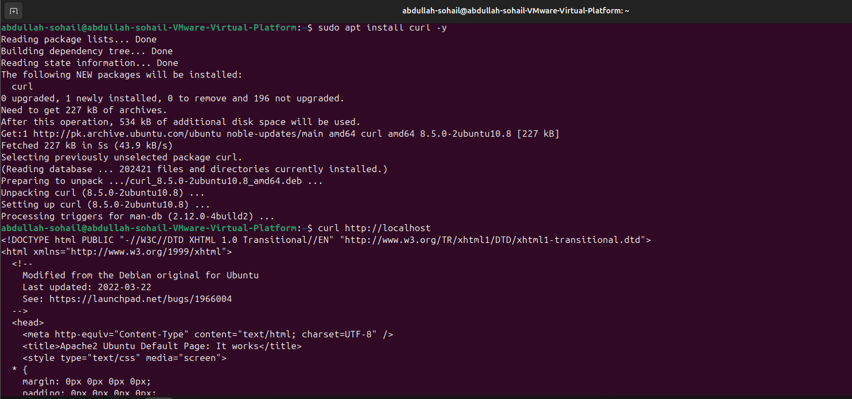
- Make a website and run it on localhost.
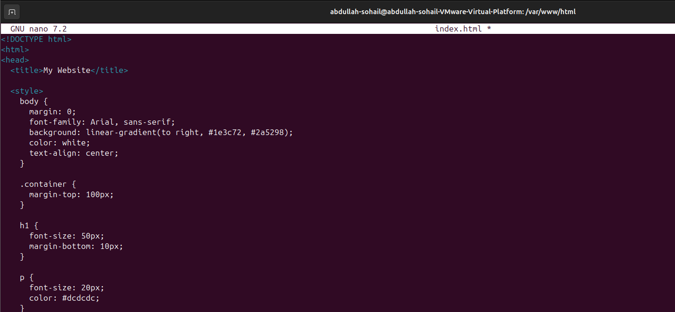

- Enable a Firewall and restrict the traffic from specific IP Address.
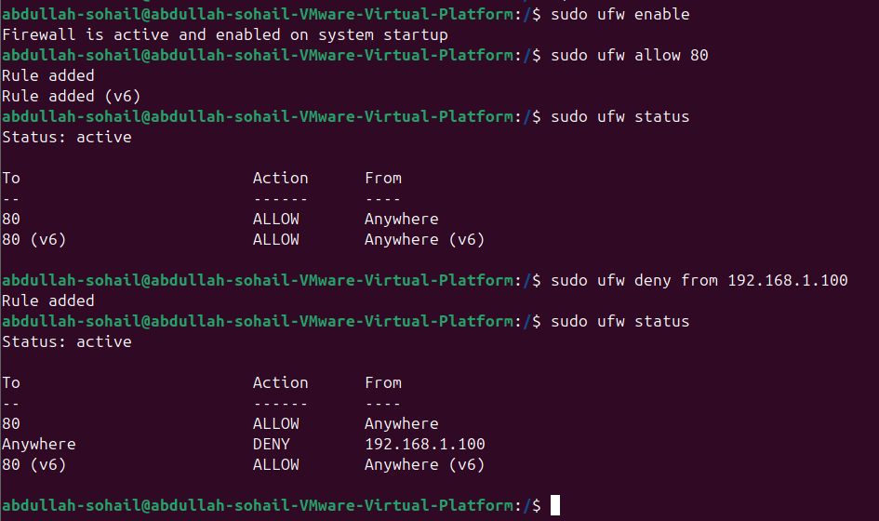
- Create two users one can access a website other is not.
